CareRing — Edge‑First Loneliness Inference & Connection Support System

Avery Guo, Hanson Zhang, Zhengtao Duan

ETEC306 — Project

Electronic Engineering Technology

School of Engineering Technology & Applied Science (SETAS)

Centennial College

**Supervisor/Instructor:** ________________________________  
**Date of Submission:** September 14, 2025

Introduction

Loneliness and social isolation will cause poorer health and lower quality of life for the elderly and people with disabilities. However, loneliness is a status that is hard for caregivers to observe. CareRing proposes a privacy‑preserving embedded system that infers *possible loneliness* from non‑intrusive sensors and routine patterns, and then prompts supportive actions (family call, check‑in, engagement cues). The system blends multi‑room motion sensing, bed/chair occupancy, door activity, voice‑presence counts (no audio recorded), and a simple mood input. Edge nodes summarize data hourly and publish to a secure hub/cloud where an interpretable algorithm produces a daily index and alerts, guiding timely human support.

Problem and Methodology

## A) Problem

At home or in a long‑term care center, staff and family members always lack continuous visibility into the senior's psychosocial well-being. Traditional fall or vitals monitors do not capture *engagement* or *routine variety*—key correlates of loneliness. Infrequent check‑ins can miss emerging trends such as prolonged bedtime, low room‑use entropy, fewer visitors, reduced speech presence, and self‑reported low mood. The engineering challenge is to acquire these signals with minimal intrusion, perform on‑device feature extraction (to protect privacy), fuse signals into an interpretable index, and actuate gentle, constructive interventions—while meeting constraints of cost, power, connectivity, and data security.

**B) Methodology**

**Approach:** Design ESP32‑S3 edge nodes (Wi‑Fi/BLE, FreeRTOS) to read sensors (PIR, reed switch, load cell + HX711, I2S microphone for VAD counts only, 3‑button mood pad) and compute hourly features (e.g., room entropy, speech‑minutes, bed‑minutes, visitors). Publish JSON via MQTT/TLS to a local hub (Raspberry Pi or ESP32 hub) and onward to cloud functions that compute a daily Loneliness Index using robust statistics (median/MAD, EMA smoothing) and alert hysteresis (yellow/orange/red). Optional anomaly detection (Isolation Forest or One‑Class SVM) provides a second opinion, keeping rules primary for explainability.

**Interfaces/communications:** GPIO (PIR/reed/buttons), I2S (mic), I²C (OLED/e‑paper), SPI (flash), UART (debug), MQTT over TLS (network), BLE (provisioning). OTA firmware updates are signed; BLE MACs hashed with rotating salt; no raw audio/video leaves devices.

**Subsystem block diagram**

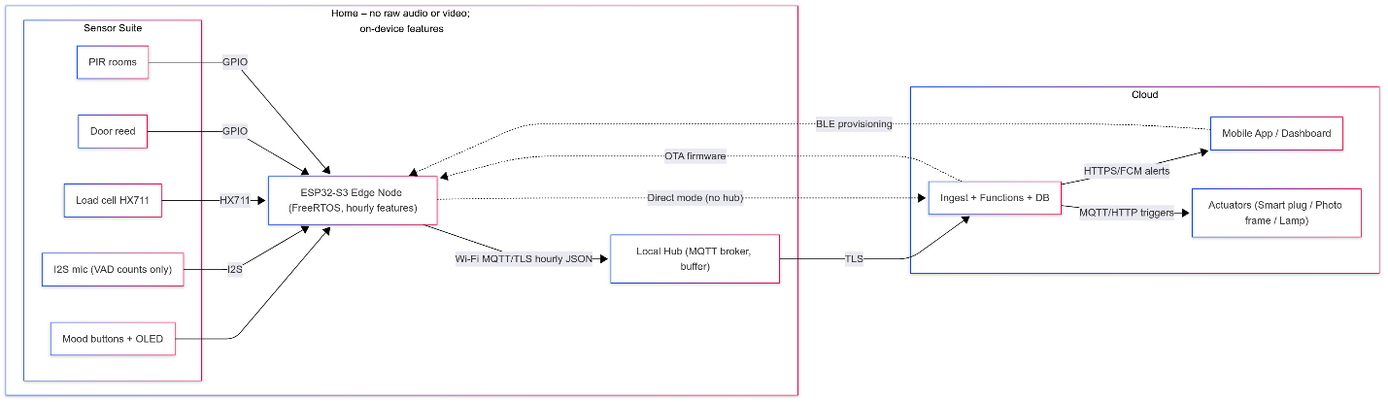

**Research & documentation:** Evaluate VAD edge models; characterize PIR placement and HX711 thresholds; implement privacy and consent UX; validate index vs weekly UCLA‑3 self‑report during pilot.

Project Objective

Deliver a working prototype that:

* **Detects signals:** multi‑room activity, bed occupancy, door events, visitor proxy (BLE dwell), speech‑presence minutes, and mood input.
* **Computes index:** daily Loneliness Index L_smooth ∈ [0,1] from transparent rules: interaction and activity composites, routine‑deviation score (MAD‑normalized), and self‑report weighting; EMA smoothing (α≈0.3).
* **Alerts responsibly:** hysteresis thresholds (≥0.6/0.7/0.8) for yellow/orange/red to prevent flapping; includes *explainable* factors (e.g., “low room entropy + ↓speech”).
* **Acts gently:** triggers supportive interventions (photo‑frame playlist, bedside light, call prompt) and provides one‑tap caregiver contact.
* **Protects privacy:** on‑device feature extraction; no raw audio/video; encryption in transit/at rest; pause monitoring control; data retention defaults (hourly 30 days; daily 6 months).
* **Meets constraints:** per‑home kit COGS ≤ $300 for 3 nodes + bed sensor + hub; install ≤ 60 min; data completeness ≥ 90% windows/week; false alerts ≤ 1 per week after calibration.

**Measurable outcomes:** Pearson/Spearman correlation of L_smooth with UCLA‑3 ≥ 0.5 after two‑week personalization; AUC ≥ 0.75 for days self‑reported as amber/red; device uptime ≥ 99% during the live phase.

Schedule of Deliverables

**Assumed timeline:** Sep 15 – Dec 5, 2025 (12 weeks)

**Roles (edit names as needed):**  
- *Member A (Hardware/PCB/Enclosure):* schematics, PCB bring‑up, sensor placement tests.  
- *Member B (Firmware/Embedded):* FreeRTOS tasks, drivers, feature extraction, OTA/TLS.  
- *Member C (Cloud/Mobile):* MQTT broker, functions, DB, dashboard/mobile, alerts.

**Milestones & Deliverables:**

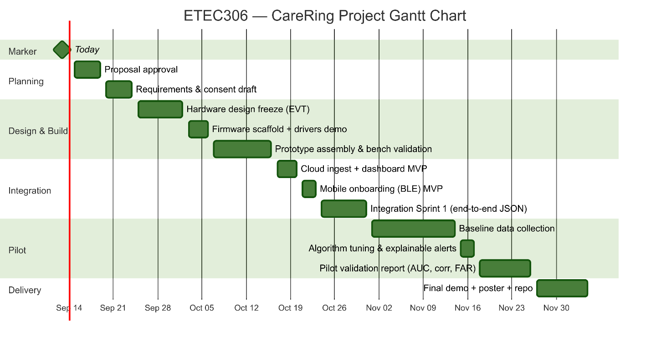

1. Proposal approval — Sep 19
2. Requirements & ethics/consent draft — Sep 24
3. Hardware design freeze (EVT) — Oct 3
4. Firmware scaffold + drivers demo — Oct 7
5. Prototype assembly & bench validation — Oct 17
6. Cloud ingest + dashboard MVP — Oct 21
7. Mobile onboarding (BLE) MVP — Oct 24
8. Integration Sprint 1 (end‑to‑end hourly JSON) — Oct 31
9. Baseline data collection (10–14 days) — Nov 1–14
10. Algorithm tuning & explainable alerts — Nov 18
11. Pilot validation report (AUC, corr, FAR) — Nov 27
12. Final demo + poster + code repository — Dec 5

References

Avia Semiconductor. (n.d.). *HX711: 24-bit analog-to-digital converter (ADC) for weigh scales* [Data sheet]. [https://cdn.sparkfun.com/datasheets/Sensors/ForceFlex/hx711_english.pdf](https://cdn.sparkfun.com/datasheets/Sensors/ForceFlex/hx711_english.pdf?utm_source=chatgpt.com)

Espressif Systems. (n.d.). ESP32-S3 technical reference manual [Technical reference manual]. <https://www.espressif.com/sites/default/files/documentation/esp32-s3_technical_reference_manual_en.pdf>

Espressif Systems. (n.d.). *ESP-IDF programming guide* [Documentation]. <https://docs.espressif.com/projects/esp-idf/en/stable/esp32/index.html>

FreeRTOS. (n.d.). *FreeRTOS kernel documentation: Books and manual*. <https://www.freertos.org/Documentation/02-Kernel/07-Books-and-manual/01-RTOS_book>

Hughes, M. E., Waite, L. J., Hawkley, L. C., & Cacioppo, J. T. (2004). A short scale for measuring loneliness in large surveys: Results from two population-based studies. *Research on Aging, 26*(6), 655–672. <https://doi.org/10.1177/0164027504268574>

Standards Council of Canada. (2023, November 21). *Audio/video, information and communication technology equipment – Part 1: Safety requirements (Notice of intent: CSA C22.2 No. 62368-1).* [https://scc-ccn.ca/standards/notices-of-intent/csa-group/audiovideo-information-and-communication-technology-3](https://scc-ccn.ca/standards/notices-of-intent/csa-group/audiovideo-information-and-communication-technology-3?utm_source=chatgpt.com)

TDK InvenSense. (n.d.). *INMP441 digital I²S microphone datasheet* [Data sheet]. <https://invensense.tdk.com/wp-content/uploads/2015/02/INMP441.pdf>